Add Total Fx and Dose Column to Treatment Chart

# Purpose

When a patient has multiple plans, it is often useful to display the total number of fractions and total dose in the Treatment Chart. For example, the screenshot below shows an original plan and an adaptive.

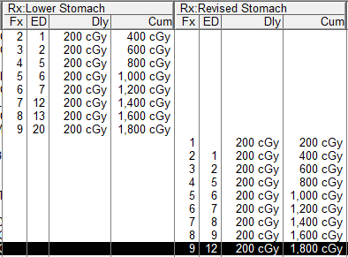

# Steps

1. Open the patient. In **D & I**, click **Dosimetry**.



1. Under **Dose Site**, click **Add**.



1. Name the dose site *Total* and click **OK**.

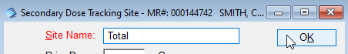

1. Under the new Dose Tracking Site, add a value of 1.000 for each beam in each plan to be included in the total. In the example, these plans are Lower Stomach and Revised Stomach. Click Close.

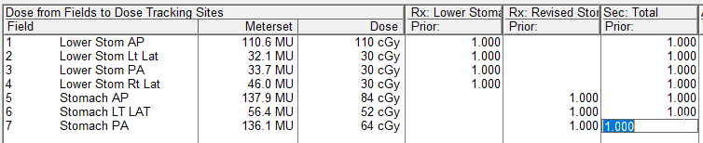

1. You should see the new column in the Treatment Chart.

